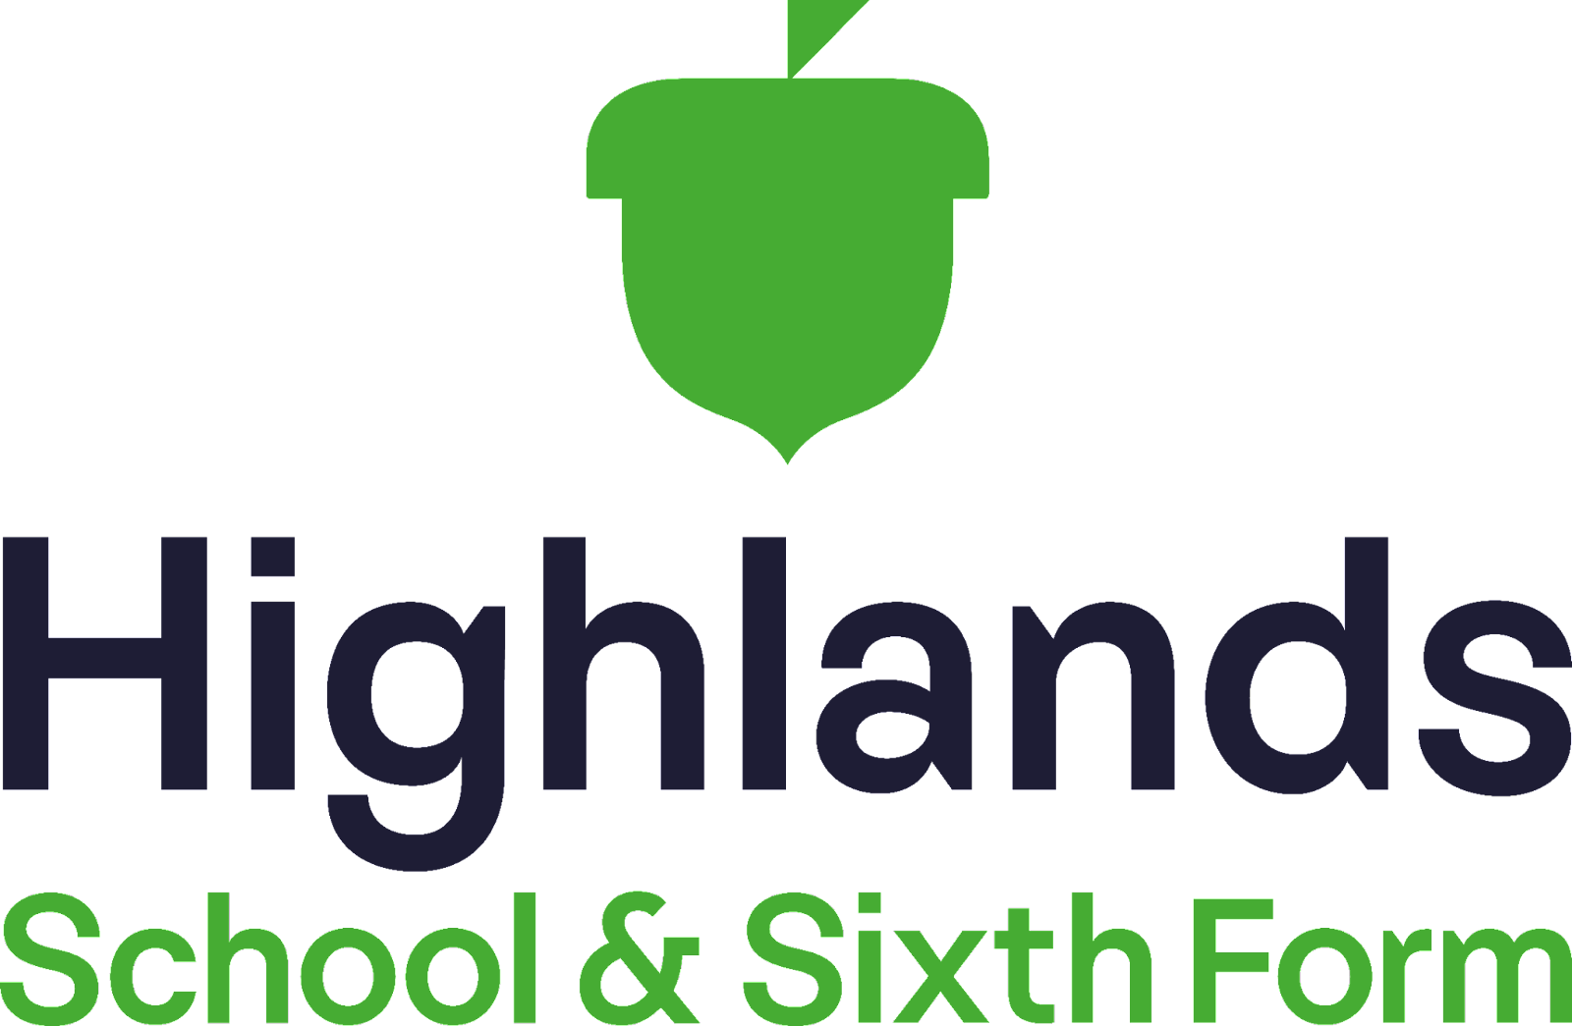

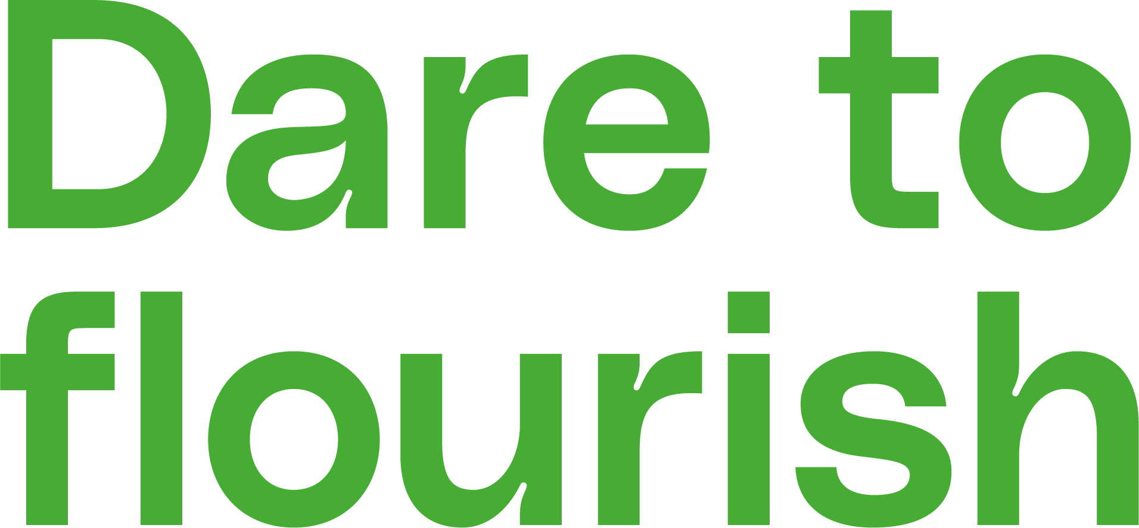

Music development plan summary

Governor Committee | School Standards and Performance
Reviewed on | November 2025
Next review | November 2026

Contents
Section 1: Overview 2
Section 2: Curriculum music 3
Section 3: Co-curricular music 3
Section 4: Musical experiences 5
Section 5: In the future 6

Section 1: Overview

Detail | Information
Academic year that this summary covers | 2025-2026
Date this summary was published | June 2024
Date this summary will be reviewed | September 2025
Name of the school music lead | Ms Miller
Name of school leadership team member with responsibility for music (if different) | Ms Husseyin
Name of local music hub | Enfield Music Service
Name of other music education organisation(s) (if partnership in place) | We have recently worked with Paul on Live music events in Enfield Town.

Section 2: Curriculum music
This is about what we teach in lesson time, how much time is spent teaching music and any music qualifications or awards that pupils can achieve.
The music curriculum.
The music department at Highlands School delivers a sequenced and ambitious music curriculum. For more information please click here. Information about the number of hours devoted to music education can be found here, and this link provides further information about the opportunities pupils have to learn to sing or play an instrument during lesson time.

Section 3: Co-curricular music
At Highlands School we offer students the opportunity to sing and play music, outside of lesson time.
Music tuition summary.
One-to-one instrumental and vocal lessons as well as paired instrumental and vocal lessons are offered on the following instruments via the Enfield Music Hub:*
- Acoustic guitar
- Electric guitar
- Bass guitar
- Voice
- Flute
- Saxophone
- Clarinet
- Bassoon
- Trumpet
- Trombone
- Euphonium
- French Horn
- Piano
- Electric Keyboard
- Drum Kit
- Cello
- Violin
*Instrumental paired lessons are subsidised for LAC and PP students.

Ensembles.
The following ensembles are available for students to join. These take place during the school day and during our Ed-Extra programme and are free to all students.
- 10 house rock bands (KS3)
- 4 Rock Bands (KS4)
- 7 steel pan ensembles (KS3-4)
- 1 guitar ensembles (KS3/4)
- Orchestra (all year groups)
- KS3 drumming ensemble (KS3)
- KS3 keyboard club (KS3)

Further opportunities.
Outside of class music lesson time, students are able to make further progress by joining any of the above ensembles or 121 and paired tuition via the Enfield Music Hub.
Students are able to take practical exams on their instrument/voice via these 121 and paired lessons such as:
- ABRSM (Associated Board of the Royal Schools of Music), performance grades
- TCL (Trinity College London) practical exams in Classical, Jazz, Rock and Pop
- RSL (Rock School LTD) practical exams for Guitar, Drum kit, bass, vocals etc
Pupils are able to practise their instruments after school using the department’s suite of music practice rooms. Students are also given the following opportunities to perform:
- End of Term Concerts/Recital Evenings
- Live music assembly week at the end of each term
- Open evening performances
- School production performances
- DARE Days for year 7 and 8

Section 4: Musical experiences
Musical experiences
Highlands School offers a range of opportunities for students to take part in musical events and opportunities. These include:
- Open evening for prospective year 7 students (October)
- Winter concert (December)
- Battle of the bands evening (March)
- Summer concert and/or school musical production (July)
- Live music in assembly week at the end of each term.

Trips and visits
Students at Highlands have the opportunity to engage in a variety of music-based trips and visits. These include:
- GCSE Musical theatre trip (Wicked by S. Schwartz)
- Live music concerts
- Performing arts DARE Days (activities days for year 7 and 8)
- Modulo - Orchestras for All (Performing activity alongside other schools at The Royal Academy of Music and Cecil Sharp House) (2025)
- Trip to music studio for the ‘Battle of the bands’ winners.

Section 5: In the future
This is about what the school is planning for subsequent years.
Practical music making.
- The music department plans to increase the number of students who can access practical music making. This process started in 2022-23 with four House Rock Bands and has continued in 2025 to now have 14 House rock bands. Teacher hours permitting, we would like to continue this offer into 2026.
- We have continued the offer into year 9 but choose students who have picked core music for the Arts Option and therefore have 2 year 9 rock bands. This allows us to have more GCSE bands in year 10 and 11 to support students with their ensemble performances.
- We provide performing opportunities via the funded steel pan ensembles and the orchestra. Numbers are increasing with now 18 members of the orchestra across years 7-13. The music department is looking to start a Highlands School Choir and a proposal has been put forward to look at how this can take place during the school day with an external provider
Opportunities to perform
- Live Music Assemblies started in 2023/24 and will continue into 2025/26). This has been very popular and students like the opportunities to perform to an audience. This programme will be continued.
- 2025
- Work continues to refine the music curriculum.

